
AGENCY FOR ELECTRONIC COMMUNICATIONS AND
POSTAL SERVICES

PRESS RELEASE

The Agency for Electronic Communications and Postal Services of Montenegro (EKIP) organizes International Conference, titled „Current and Future Regulatory Challenges, Harmonisation with the European Regulatory Framework˝, to be held from 26 to 28 September 2022 in Budva.

This year, the 19th Conference will be held as one of the leading gatherings of regulators in the region of Central and South-eastern Europe, where various aspects of the regulation of electronic communications market are discussed.

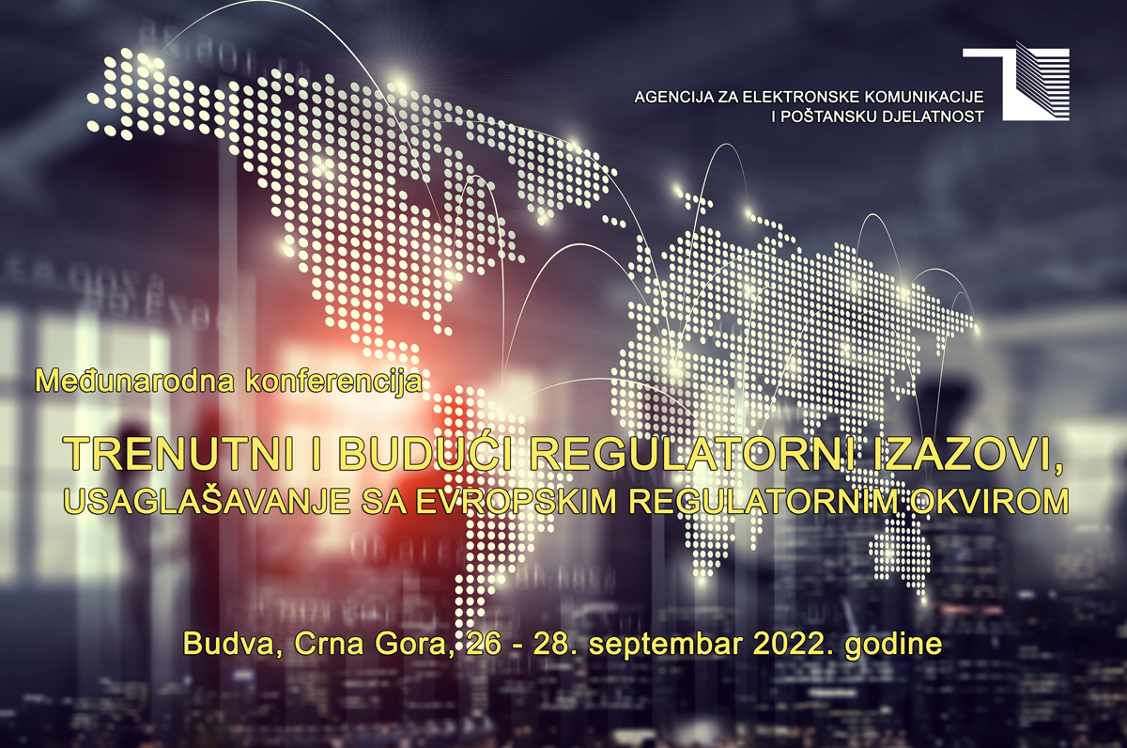

This year, as part of the official program, eight program sessions will be held covering current and useful topics both for Montenegro and for the Region. These issues have been structured in the manner to be addressed from the engineering, economic and legal regulation aspects. This will be a great occasion for experts – engineers coming from national regulatory bodies, operators and international institutions, to share their experiences on 5G implementation, greater network accessibility and service quality, digital transformation and development of broadband access and electronic communications infrastructure, safety and security of electronic communications networks and services, introduction and implementation challenges of digital radio, focusing specifically on the practise and harmonization with the European regulations relevant for these matters. Furthermore, Conference attendees will deal with the issues related to strengthening user protection, promotion of competitive market, market analysis, and applied regulatory measures, as well as with the results and benefits of the implementation of international roaming (RLAH) between the Western Balkan countries (WB6), and further activities on concluding adequate roaming agreement between WB6 countries and the EU members.

The interest in participating in the Conference is exceptional, so this year we have witnessed the highest interest in the Conference compared to 18 conferences previously held. About 150 participants are expected to come. In the Conference will participate: the representatives of 13 national regulatory agencies, 2 ministries and 1 state administration, 3 international institutions (ITU, WorldDAB, RCC), 11 companies, 7 operators, while 29 presentations will be held by the experts. In total, the Conference will be attended by the participants from 15 countries.

The Conference will be opened by Mr. Branko Kovijanić, President of the Council of EKIP, and the participants will be also greeted by nine directors, presidents, or members of the Councils and Boards of Directors of the agencies which will take part in the Conference.

As in previous years, the leading Montenegrin operators - Crnogorski Telekom, One Crna Gora and Telemach have supported EKIP in the organization of the Conference itself and together they will all host the gala dinner organized for all Conference participants.

